Azure Managed Identities - Full Explanation
Cloud Scholars
https://www.youtube.com/watch?v=evhkGWSwQIA

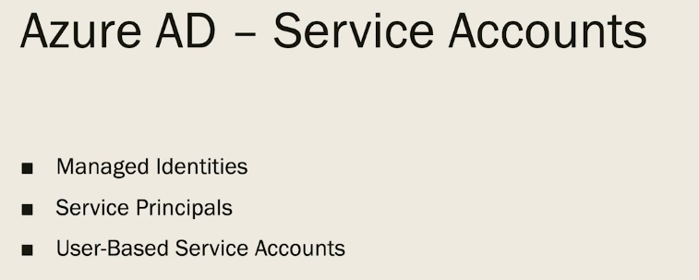

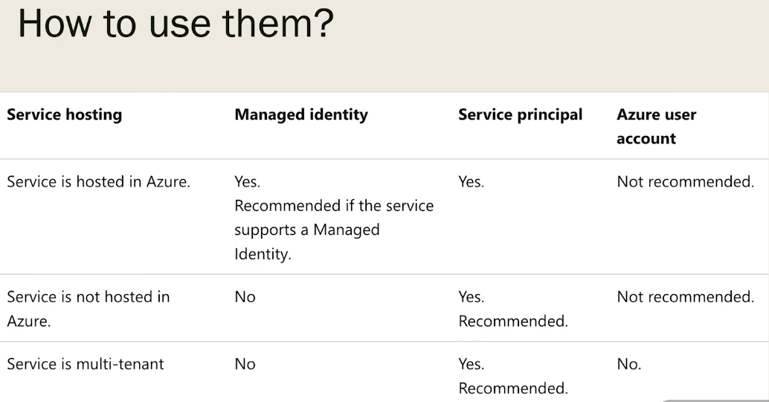

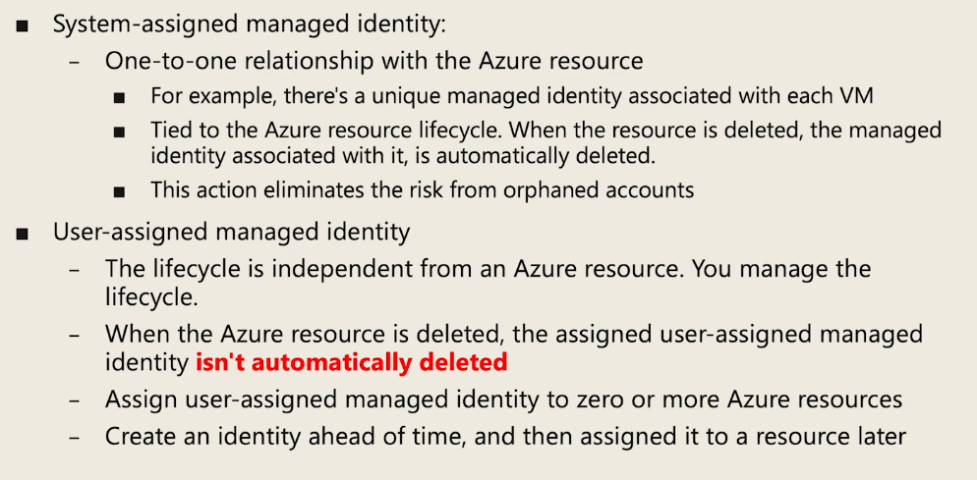

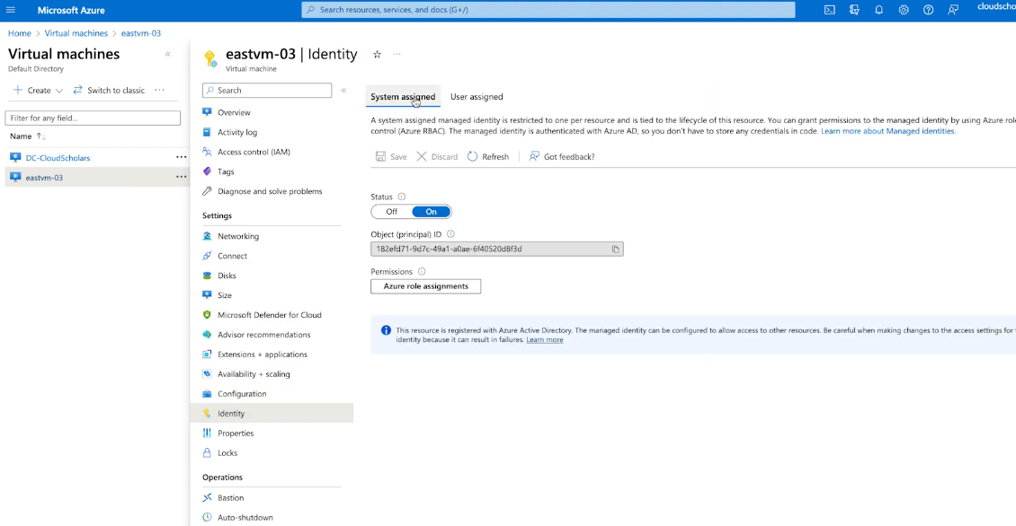

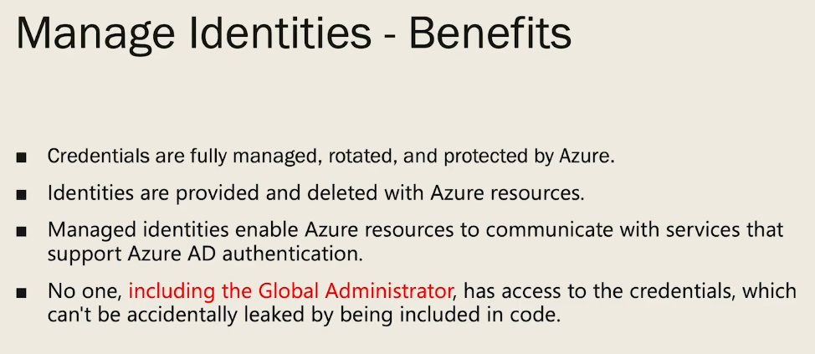

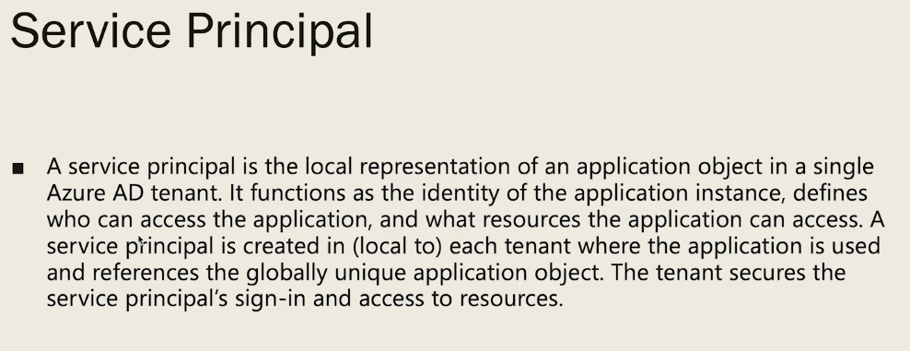

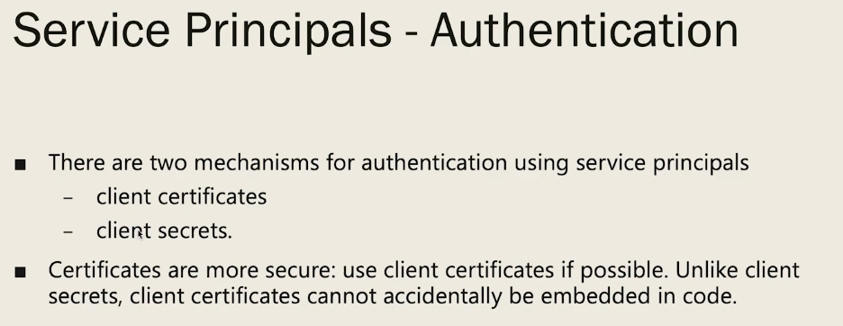
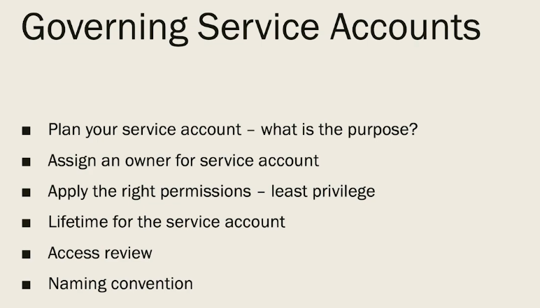

System Assigned vs User Assigned Managed Identity Explained
Kamal Rathnayake - MVP
https://www.youtube.com/watch?v=tFzIjBIlWUw

Difference between Azure User Manage Identities vs System Manage Identities
https://www.youtube.com/watch?v=yGlFDhfQwwk

Stop Using Client Secrets in Azure | Managed Identity Explained
Cloud With Aarya
https://www.youtube.com/watch?v=y3XofKMKU6Q

